**CSC 371/471 Mobile Application Development (iOS)**

**Final Project Documentation**

**Project Title:** Kanji Learning Game (Kanji Master)

**Name:** Fernando Araujo

**Project Type:** Individual Project

**Project Description**

As previously defined in the Final Project Proposal, this project focuses on the design and implementation of a Kanji learning app. While this app is indeed focused around learning Japanese and Kanji, it has been coded in a general way such that it can be used to memorize anything else.

The application has three main areas or features. The first one is the Kanji Memorization game itself. This feature can be accessed from the Main Menu of the application as follows: (Touch to start -> New Game)

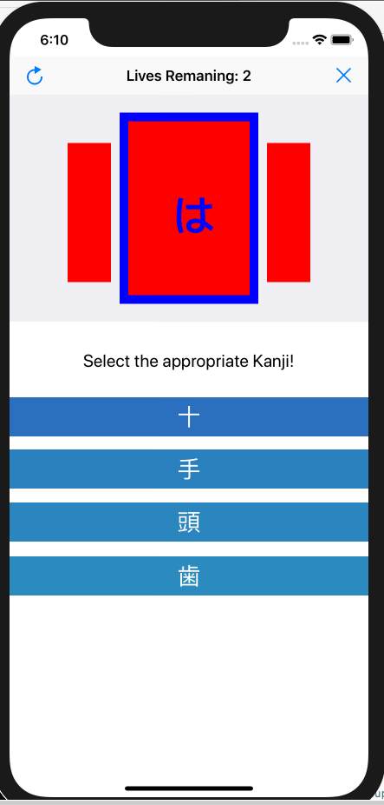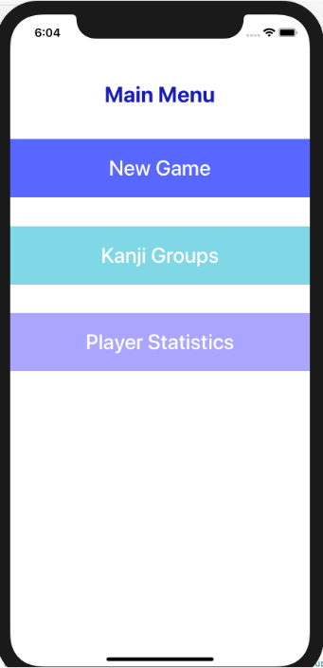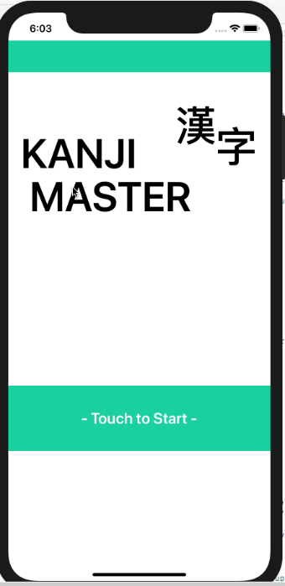

The Game Screen: The main feature of this application. Includes animations, and memorization tests

The Main Menu: The main access for the 3 main features the application. Includes buttons for New Game, Kanji Groups and Player Statistics

The Title Screen: it shows the game title and serves as the introduction for the rest of the application

At the top of the game screen you can see the number of lives you have (you are given 2 per game). The canvas view directly underneath showcases the main Kanji or Hiragana word that you will try to memorize and be tested upon. The canvas view starts a shuffling animation whenever the user navigates to this page of the application, wins or loses and restarts a match.

The objective of the game is simple, to try to guess the Kanji, meaning and Hiragana word. The user is given 4 options to choose from and must choose the most appropriate answer depending on what the game asks at the moment. The game has 3 basic questions picked at random, which requires the user to know not only the meaning of the Kanji, but also its reading in Hiragana and to be able to recognize a specific character amongst others.

The second main feature is the Kanji Groups page, which can be access via Main Menu Kanji Groups button. This page allows the user to manage the lists of Kanji he wants to study. The user is able to create new Custom Groups and Kanji entries. This page is based on a nested Table Views based both on Kanji Groups and the lists of individual Kanji within them.

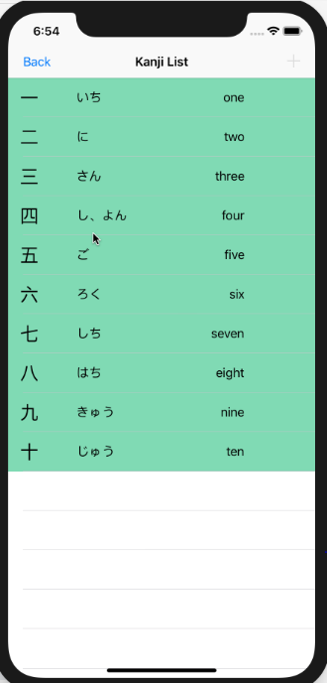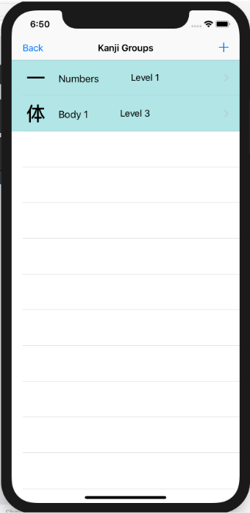

Another feature within this section of the application is the ability create both new Kanji groups and the Kanji within them, by just clicking on the + button. This allows for further expansion of vocabulary and for the user to really focus on the characters that he wants to study. The user can also access the Kanji Details page in order to review all the Kanji in the application one by one, before taking on the actual game.

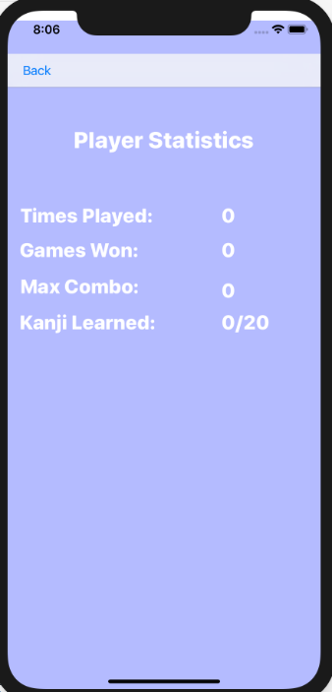

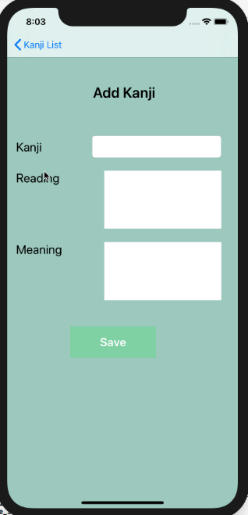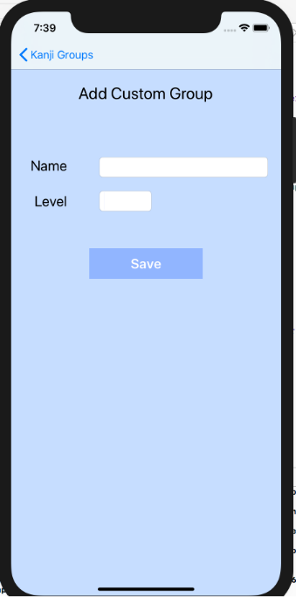

The last major feature of the application is the Player Statistics page. While this page may look a bit simple, it provides a lot of information based on the current games that the User has played. It highlights the number of tries, the number of successes, amount of Kanji available, how many can be deemed as already learned (once the user achieves consistent scores for a given Kanji Group or Kanji), etc. Along with this page, the Kanji Groups and Objects are also used to track information regarding a user’s performance. They record the number of times they have been attempted, both successfully and unsuccessfully and record how easy or difficult they are for the user.

**Final Project Discussion**

**API Features**

For this application I utilized Quartz 2D to create both the images and animations that were required in order to create the Game Screen. I also utilized Dynamic Table Views for both the Kanji and Kanji Group views. This allowed me to present the information seamlessly in a user-friendly fashion. Creating multiple prototype cells and customizing the Dynamic Tables is very rewarding, since it makes your application look both intuitive and refined.

The Navigation Controller was also used extensively throughout my application. Almost every movement between scenes was accomplished by harnessing the power of the Navigation Controller. I think that being able to use this controller correctly greatly enhances the look and feel of the application. It makes it more familiar, since people are overall used to its interface.

**Challenges**

Some of the biggest challenges I encountered had to do with issues that were not covered in lectures at all. For example, I did not know very well how to implement nested Dynamic Table Views. This proved to be challenging, since at first I attempted to add more than one Navigation Controller with them. Everything seemed to be working, but I had a real challenge passing data around between controllers. It wasn’t until I researched a bit and found out that my approach was not correct, that I was able to get the application working as expected.

I also had some issues when trying to animate my drawings with Quartz 2D. While in theory it may not be that difficult, getting in the mind set of coordinates and point movement takes some time. I used the Quartz 2D on my Kanji Game page in order to give it a feel like the computer is shuffling a deck of Kanji cards, before asking you the question. I would have liked to delve into this area of graphics and animation in a mobile environment more throughout the class.

Since I challenged myself by trying to create a sizable application from scratch, the amount of work did seem to be a bit heavy. Nevertheless, I believe that I was able to hit on all the points required for this assignment. I am also very happy, since I made this application with the intent of using it myself to study. I already have many ideas on how to improve it and what the next steps need to be in order to make it a more mainstream or marketable app.

**Future Improvements**

I believe that some important features are still missing from my application. One of them would be being able to delete both Kanji Groups and individual Kanji. I also think that I can improve both the game mechanics and the animation and make it a bit more entertaining. Other than that, adding the necessary code in order to be able to store data in a local database, improve my application’s efficiency and load time, and also take more meaningful player statistics would be very good improvements.

I would really like to make this application into a more fleshed out game, with characters, levels and a world. I think that normal flash card memorization games are not very engaging. I believe that the best way to learn is to not even have to think about learning. So if you truly have fun with a game, learning will come by itself.

**IOS Development Afterthoughts**

I really enjoyed working on IOS development throughout the class. This is my first experience ever, since I have never even owned a Mac PC. I found the IDE very intuitive and being able to drag, drop and connect different elements into the application make it much faster. I believe I will try to continue experimenting with IOS and see if I can make other useful application by myself after the class is over.

Even though I really enjoyed learning about IOS development, I did have some issues with regards to how secluded it is from the rest of the world. Since I do not own an iPhone nor a Mac PC, I had to jump thought a lot of hoops in order to get all my environments set up and ready for development. Even after doing so, I still have issues sometimes with the Virtual Machine that I use to both develop and run the application just becomes extremely slow, I get countless crashes of the IDE and the phone emulators even though it seems unrelated to my code. This really affects both my development and testing time. If I continue developing for IOS I will for sure try to get a secondary machine running Mac OS just for development purposes.

I am really interested in mobile development overall, this is the main reason why I joined this class. I am also planning on taking the Android Development class and a level 2 Mobile Development class. I am also very interested in the Mobile Game Development class listed in DePaul, unfortunately, I have not seen it actually being offered lately.